Please find the WFH internet bill invoice bill.

1. **26 August to 23 September**

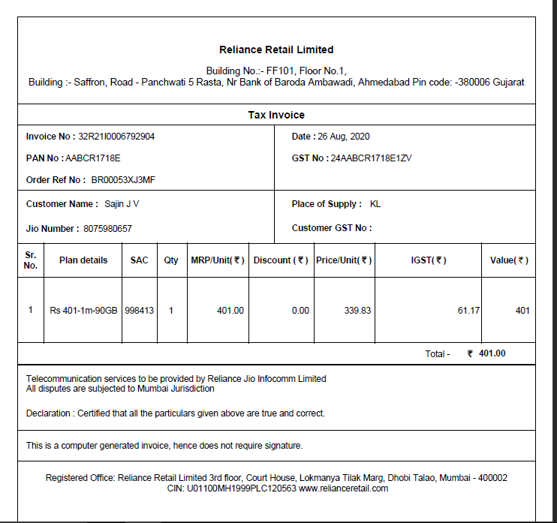

**23 September to 18 November**

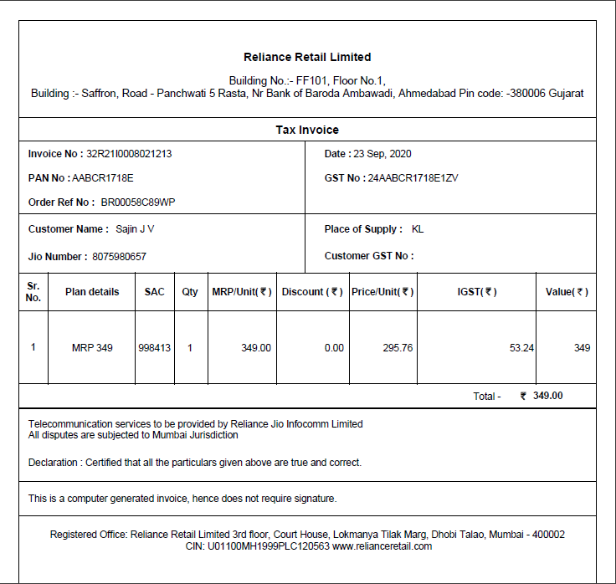

**18 November to 26 November**

